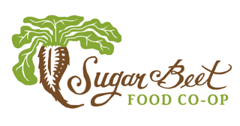

SUGAR BEET FOOD STORE COOPERATIVE

BOARD OF DIRECTORS MEETING

TUESDAY, November 13, 2018, 7:30pm

Oak Park Main Library

834 Lake St. Oak Park, IL

Board of Directors: Daniel Becker, Ryan Bradley, Eryn Cook Jim Doyle, Cindy Gradle, Bri Kellogg, Greg Kolar, Sharon Newton, Peter Nolan, Rachel Poretsky, and Janet Rouse,

GM: Chris Roland

AGENDA
- WELCOME (PETER)
- GENERAL MANAGER’S REPORT (CHRIS)
  - Sales Results
  - Q3 Financials
  - Key Initiatives
  - Owner Refunds (if any)

- COMMITTEE UPDATES
  - Compensation Committee
  - Governance / Board Development Committee
  - Strategic Plan / Finance Committee
  - Membership Committee
  - Loan Committee

- Open Topics:
  - Development on Madison St.
  - Board meeting frequency

- Q&A from audience

- CLOSING
  - Review Action Items and assign roles as needed.
  - Dates for next Board meetings
    - December offsite

- ADJOURN

