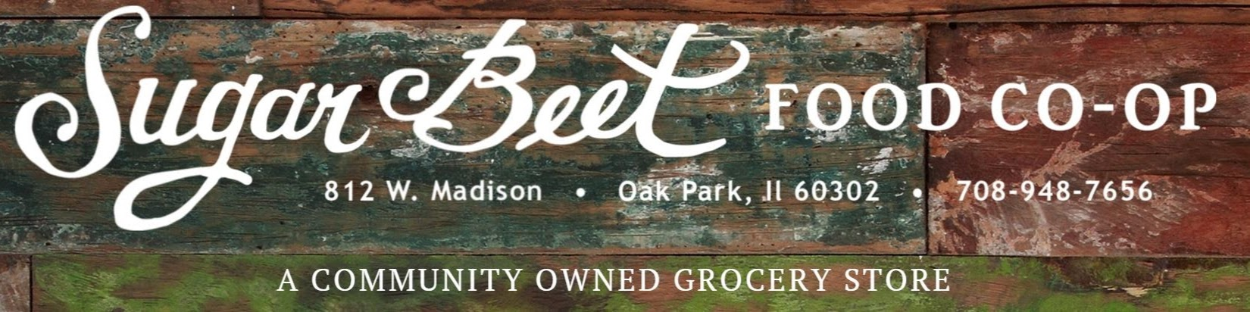
Owner Sales 2.21-2.27
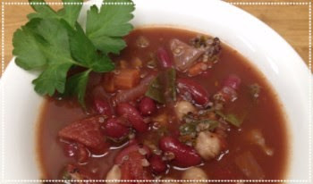 | Sugar Beet Prepared Foods  Minestrone Soup  $3.99 (16 oz Container)  Reg. $4.99 | 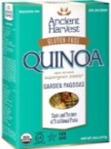 | Organic Ancient Harvest Supergrain Garden Pagodas Pasta  2 for $5  Reg. $3.89
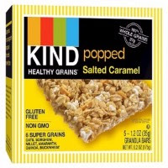 | Kind Bar  Popped Salted Caramel Bar  5 pack box  2 for $6  Reg. $4.59 | 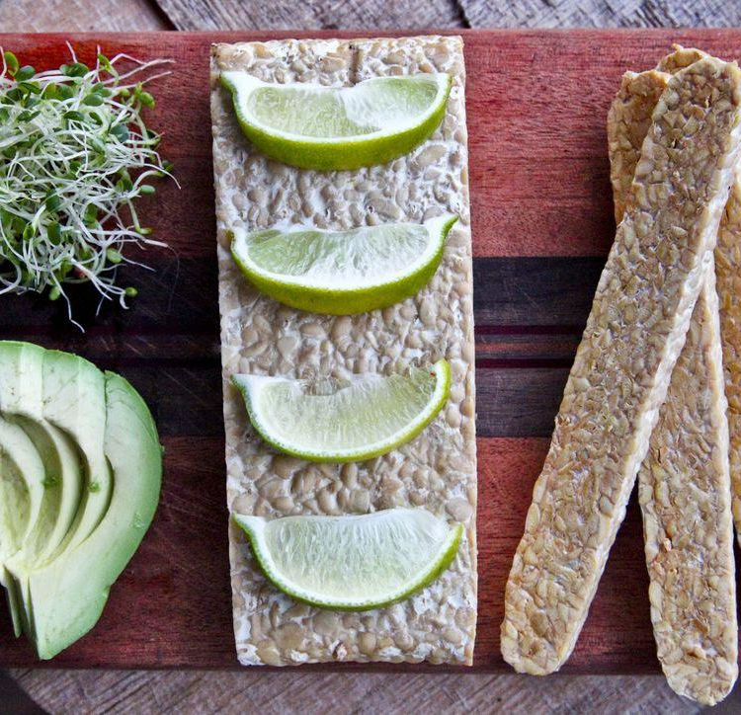 | Smiling Hara  Tempeh & Hempeh  Buy One  Get One Free  Reg. $6.99
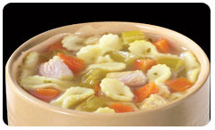 | Organic  Health Valley  Soup Varieties  2 for $6  Reg. $3.99 |  | Local Company  Ecos  Selected Cleaning Products  Stain & Odor Remover / Drain Cleaner / Creamy Cleanser  $1 off
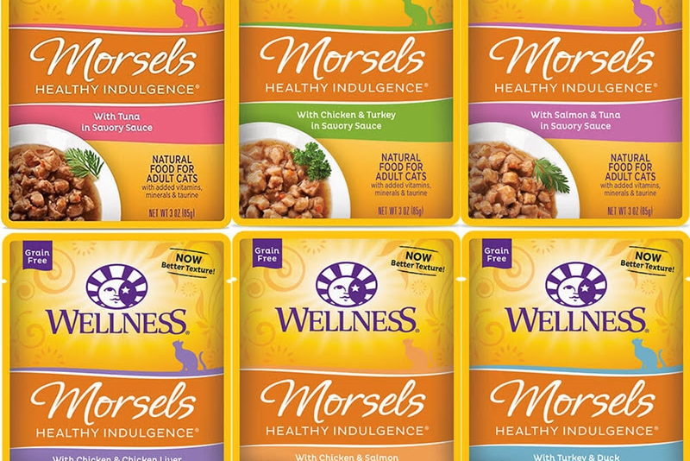 | Wellness  Cat Food Morsels  2 for $5  Reg. $3.89

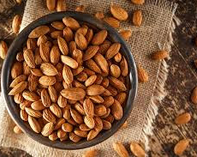 | Organic  Bulk Apple Honey or Buffalo Almonds  $4.99/lb  Reg. $24.99 | 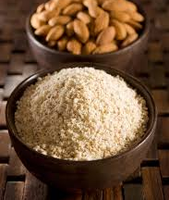 | Bulk Almond Flour  $6.99/lb  Reg. $9.99
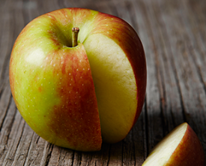 | Organic  Braeburn Apples  $1.49/lb  Reg. $1.99 | 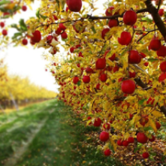 | Organic  Pink Lady Apples  $1.99/lb  Reg. $2.99
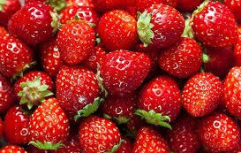 | Organic  Strawberries  $5.49  1 lb container  Reg. $6.99 | 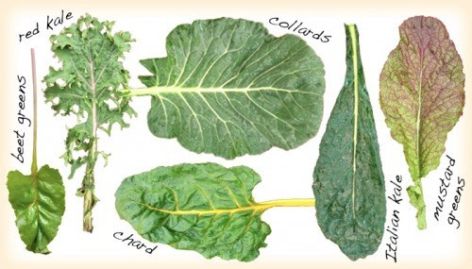 | Organic  Red Chard, Red Kale, or Collard Greens  All $1.49/bunch  Reg. $1.99

